Play testing

-Ben Miller

The Premise:

The premise presented was for the team to be able to successfully play test a game, and Agar.io was the game that was chosen as it was entirely web based. This meant that if you had access to the internet you could play this game.

It was decided for Agar.io as the ease of access allows for the vast majority to play this as there are little game requirements as most people can play this.

Questionnaire:

Quality in playtesting is what makes a game enjoyable; fun, thrilling, pleasure-seeking. This is the questionnaire that was used in order to prompt others into describing what was fun during gameplay (1 for lowest, 10 for highest):

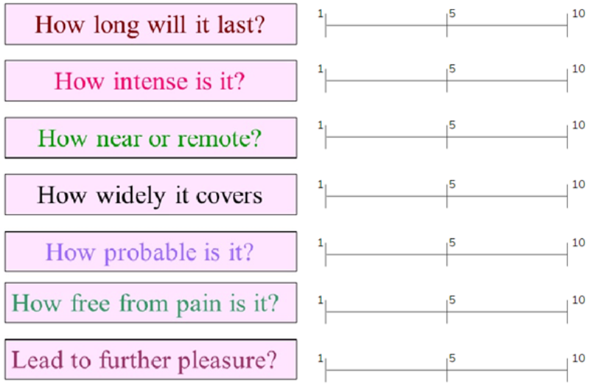

Figure 1: Shows the table for each part of the playtesting

Internal playtesting:



Figure 2: A screenshot of the play tester, playing the game

This is a screenshot of a game that was played with the play tester.

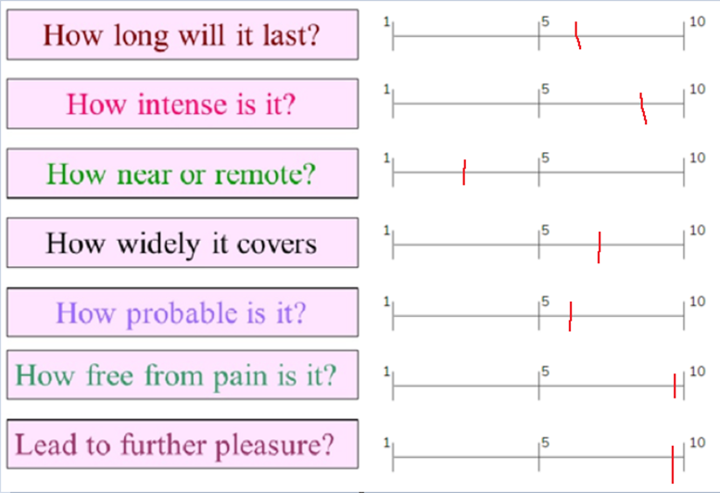

Figure 3: Shows the results of the internal playtesting

This is the results from the internal playtesting, it shows that there was only 1 answer that was below 5, this was because the play tester was having connection issues making the game less near/ harder to enjoy.

Overall the answers were 6 or above. These results meant that the game “Agar.io” is a very enjoyable game based on the playtesting results.

The play tester often kept asking questions on what the questions mean which is something the team took into account when preparing for some external playtesting.

External playtesting:



Figure 4: A screenshot of the external play tester, playing the game

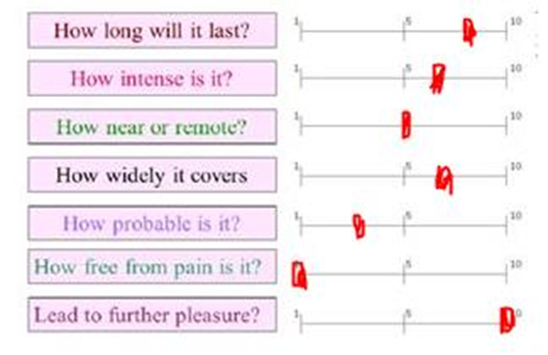

Figure 5: A screenshot of the results of external play tester

This is the results from the external playtesting, it shows that there were only 2 answers that were below 5 and that was because the play tester found that the game wasn’t very probable, and the game was free from pain.

The play tester often kept asking questions on what the questions mean, such as what the free from pain question meant, which is something the team took into account when preparing for some external playtesting.

Conclusion:

Playtesting was overall helpful to the team as it allowed everyone to understand what makes a game successful, which is the player base. Without playtesting then the game creators wouldn’t know or not if the game is actually enjoyable for others to play, and if it is not enjoyable then it can lead to the game essentially failing.

For the future, the team is aware of what to look for when playtesting, such as monitoring how much they are enjoying it, how much access they have to it, and if the player would get bored from playing it.

Team members:

Joshua Baker

Zakaria Ahmed

Ben Miller